1.Calculate the number of occurrences of a character in each row of R DataFrame.

# load ggplot2
library(ggplot2)

set.seed(0)
data <- data.frame(x = sample(0:20, 100, replace = TRUE))

# create customized stacked dot plot
ggplot(data, aes(x = x)) +
geom_dotplot(dotsize = 1.5, stackratio = 1,
fill = "darkgreen", color = "green") +
labs(title = "Stacked Dot Plot", x = "X-Axis", y = "Y-Axis")

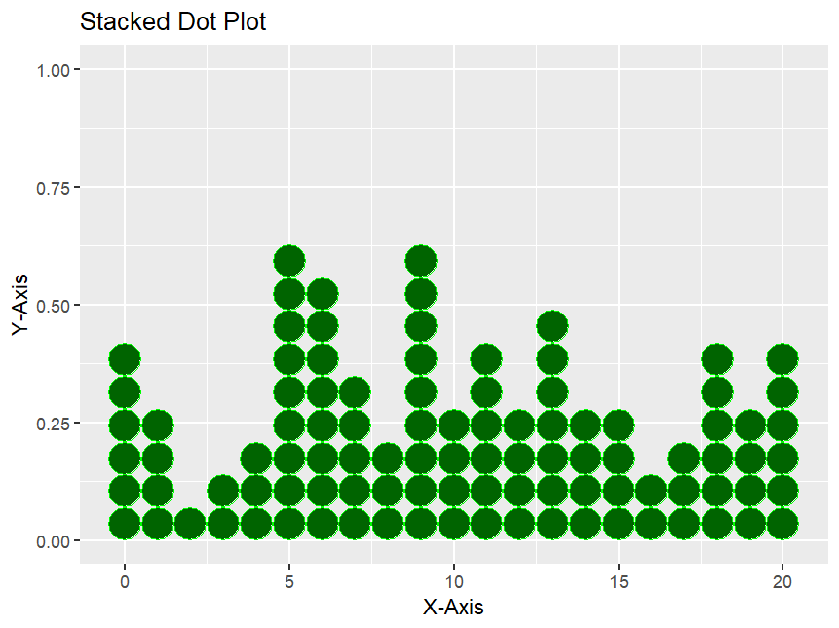

- Multiply a matrix by its transpose while ignoring missing values in R.

# Define a custom function to multiply a matrix by its transpose, ignoring NAs
multiply_by_transpose_ignore_na <- function(mat) {
n <- nrow(mat)
m <- ncol(mat)
result <- matrix(0, n, n)

for (i in 1:n) {
for (j in i:n) {
valid_indices <- !is.na(mat[i,]) & !is.na(mat[j,])
if (sum(valid_indices) > 0) {
result[i, j] <- sum(mat[i, valid_indices] * mat[j, valid_indices])
result[j, i] <- result[i, j] # Symmetric matrix
}
}
}
return(result)
}

# Example matrix with NA values
mat <- matrix(c(1, 2, NA, 4, 5, 6, NA, 8, 9), nrow=3, byrow=TRUE)

# Apply the custom function
result <- multiply_by_transpose_ignore_na(mat)

# Print the result
print(result)

Output:
[,1] [,2] [,3]
[1,] 5 14 16
[2,] 14 77 94
[3,] 16 94 145

- Adding Colors to Charts in R Programming.

# Creating a list
temp<-c(5, 10, 15, 20, 25)

# Barplot with default color
barplot(temp, main ="By default")

# Barplot with green color
barplot(temp, col ="green",
main ="With coloring")

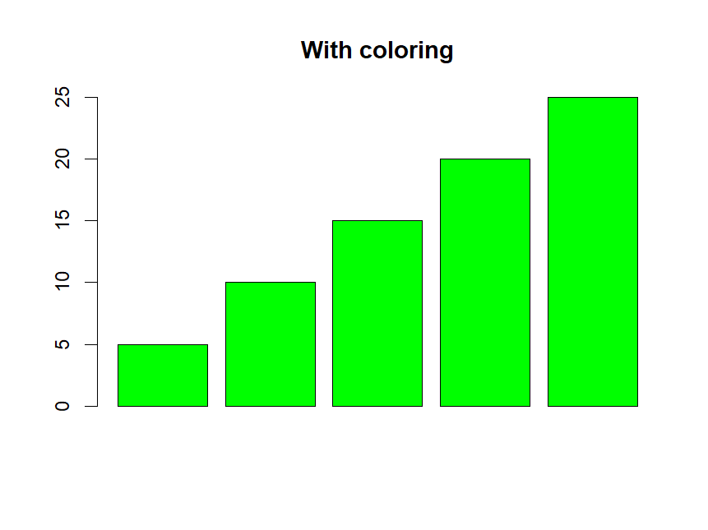

8.Plot Shaded Area between vertical lines in R.

x<-rpois(10,5)
y<-rpois(10,7)

df<-data.frame(x,y)

library(ggplot2)
ggplot(df,aes(x,y))+
geom_rect(aes(xmin=2,xmax=3,ymin=0,ymax=Inf),color="black",alpha=0)

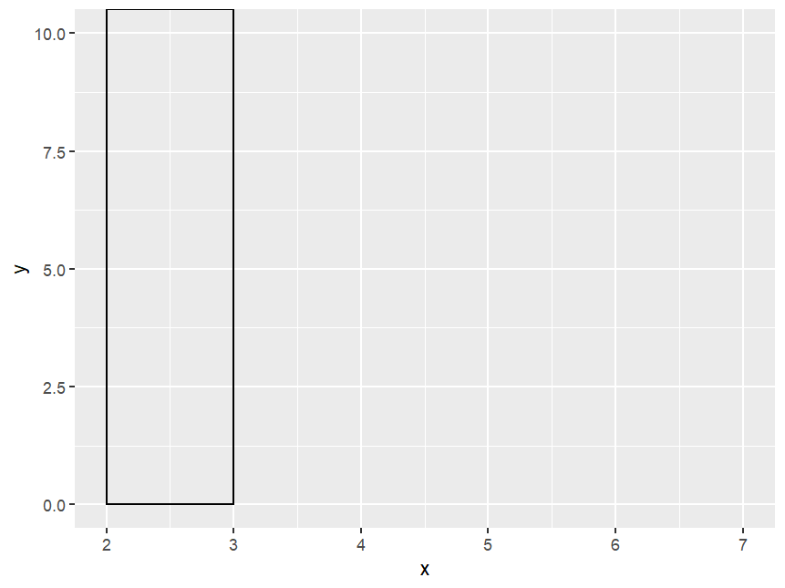

- Add Mean and Median to Histogram in.

l <- c(2, 3, 7, 8, 10, 13, 14, 15,
18, 18, 20, 26, 25, 26, 27, 28)
hist(l)

